**Thanks to** [**blog by stefan**](https://www.stefan-seelmann.de/blog/setting-up-an-ldap-server-for-your-development-environment)

**Setting up an LDAP server for your development environment**

When you need to develop an Java application that uses LDAP as a datastore it is useful to setup a local LDAP server. The [Apache Directory project](http://directory.apache.org/) provides two useful products:

* Apache Directory Server: a full-featured LDAP server completely in Java
* Apache Directory Studio: a LDAP tooling platform based on Eclipse RCP which includes ApacheDS

This tutorial shows, how to install the LDAP tools and how to setup an LDAP server for your development environment.

**Download and Install Apache Directory Studio**

[Download Apache Directory Studio](http://directory.apache.org/studio), choose the right distribution for your platform and follow the installation steps there.

If you already use Eclipse you could also install the Apache Directory Studio Plug-ins into your existing Eclipse installation.The update site is http://directory.apache.org/studio/update/1.x, choose at least "LDAP Browser", "LDIF Editor" and "ApacheDS" features. Open the "LDAP perspective after installation is finished.

**Setup and Start Apache Directory Server**

Of course you could download and install a standalone version of Apache Directory Server. However a much simpler solution is to setup the LDAP server directly within Apache Directory Studio or within your Eclipse environment respectively. Apache Directory Studio is shipped with an integrated Apache Directory Server plus some management tools.

Open the "Servers" view in the bottom left corner of the "LDAP" perspective, click the "New Server" button and enter a name like "ApacheDS for Development".

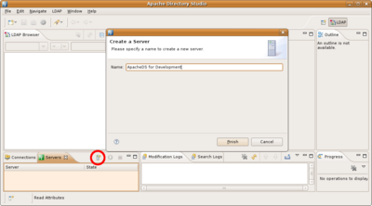

This creates a new server instance. Then you could select the server and start it by clicking the "Run" button.

Now the server runs. By default it listens to ports 10389 and 10636 (for SSL). The admin account is "uid=admin,ou=system" and the password is "secret". You could right-click the server and select "Open Configuration" in order so view and edit the server settings.

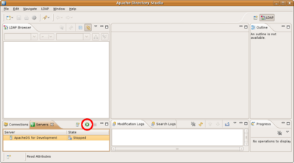

**Use the LDAP Browser to connect to the Server**

Right-click the server and select "LDAP Browser" -> "Create a Connection". Then switch to the "Connections" view, you see a new connection to the created server instance was added. Select the connection and click "Open Connection". Now you could browse the LDAP server.

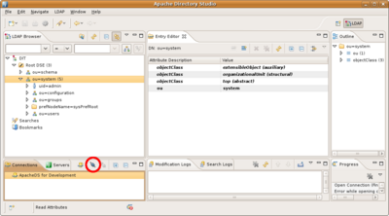

**Load some sample data**

As you see there's not much data in the server, in fact only system configuration. So lets import some example data. For LDAP there is a standardized data interchange format, called LDIF. Open a new LDIF editor (File->New...->LDAP Browser->LDIF File). In the opened editor click the "Browse..." button and select the connection. Then copy/paste the following content into the LDIF editor, ensure that there is a empty line at the end of the content. Finally click the green "Execute LDIF" button and the data slips into the LDAP server.

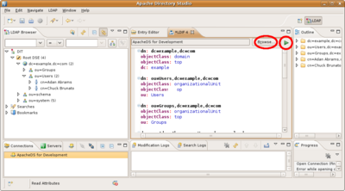

dn: dc=example,dc=com

objectClass: domain

objectClass: top

dc: example

dn: ou=Users,dc=example,dc=com

objectClass: organizationalUnit

objectClass: top

ou: Users

dn: ou=Groups,dc=example,dc=com

objectClass: organizationalUnit

objectClass: top

ou: Groups

dn: cn=Adan Abrams,ou=Users,dc=example,dc=com

objectClass: inetOrgPerson

objectClass: organizationalPerson

objectClass: person

objectClass: top

cn: Adan Abrams

sn: Abrams

description: 19741108000000Z

employeeNumber: 7

givenName: Adan

telephoneNumber: 254-323-1920

telephoneNumber: 902-451-7619

uid: aabrams

userPassword:: c2VjcmV0

dn: cn=Chuck Brunato,ou=Users,dc=example,dc=com

objectClass: inetOrgPerson

objectClass: organizationalPerson

objectClass: person

objectClass: top

cn: Chuck Brunato

sn: Brunato

description: 19650324000000Z

employeeNumber: 3

givenName: Chuck

telephoneNumber: 169-637-3314

telephoneNumber: 907-547-9114

uid: cbrunato

userPassword:: c2VjcmV0